The overhead is calculated as follows:

Overhead mark:

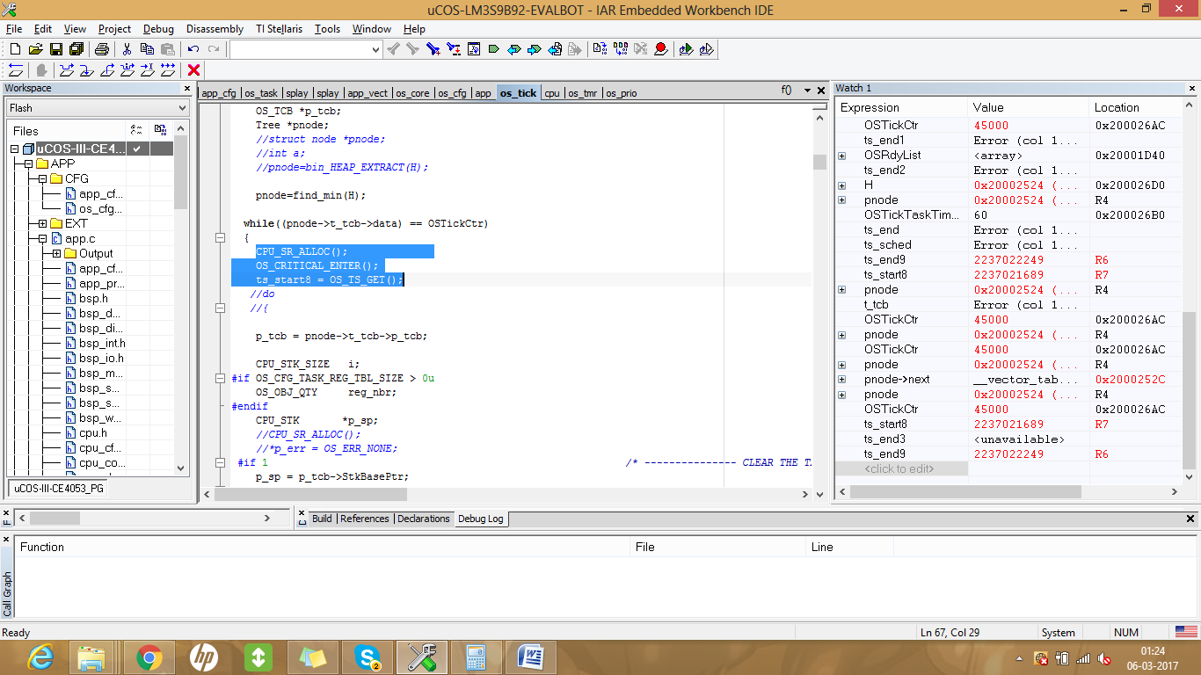

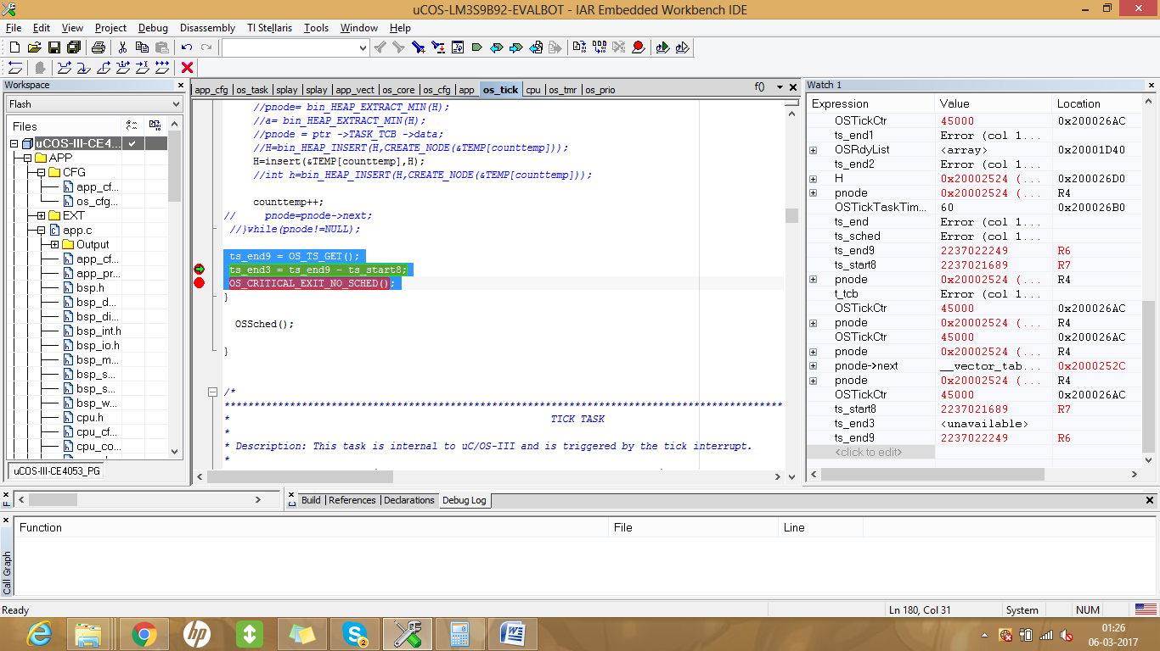

Ist overhead: 670 : deleting first minimum value task from the tree, insertion into ready list and reinserting an updated node.

2nd overhead: 485 : deleting second minimum value task from the tree and reinserting an updated node.

3rd overhead: 509 : deleting third minimum value task from the tree and reinserting an updated node.

4th overhead: 531 : deleting fourth minimum value task from the tree and reinserting an updated node.

5th overhead : 560 : deleting fifth minimum value task from the tree and reinserting an updated node.

6th overhead :560 : deleting fifth minimum value task from the tree and reinserting an updated

\*Note: when the function is being inserted into the ready list, every time its stack is being reinitialized using a loop from top to bottom. This happens since the task is completely deleted along with its particular from the tree(no local copy is maintained). This causes too much overhead.

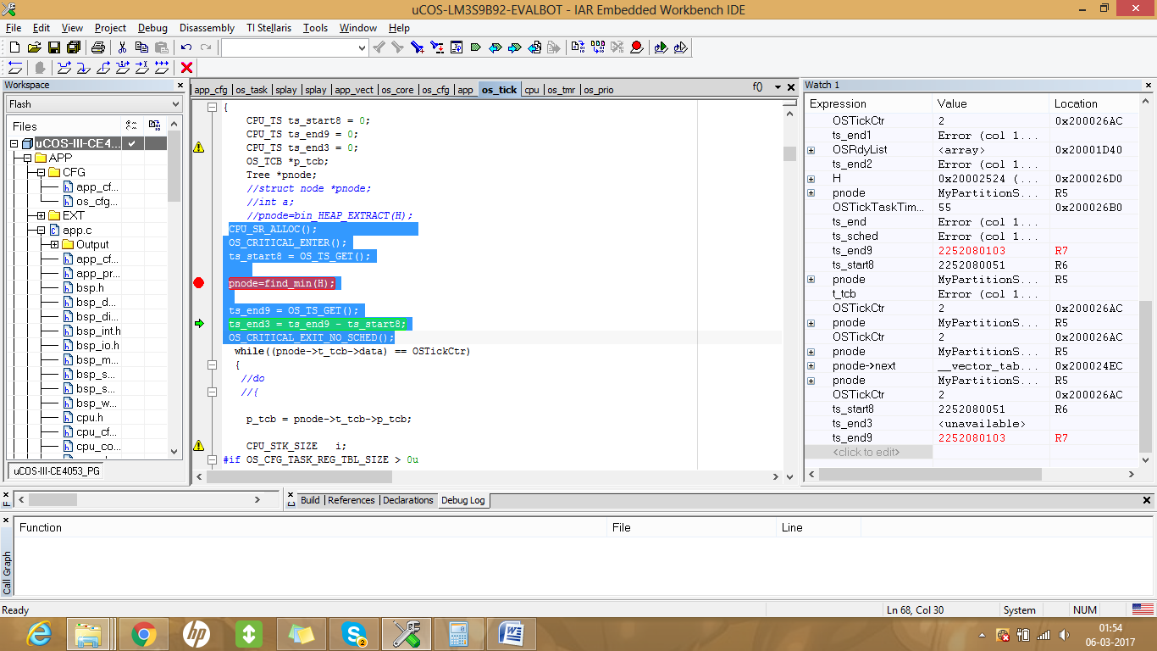

Overhead for finding first minimum value in the tree: 51

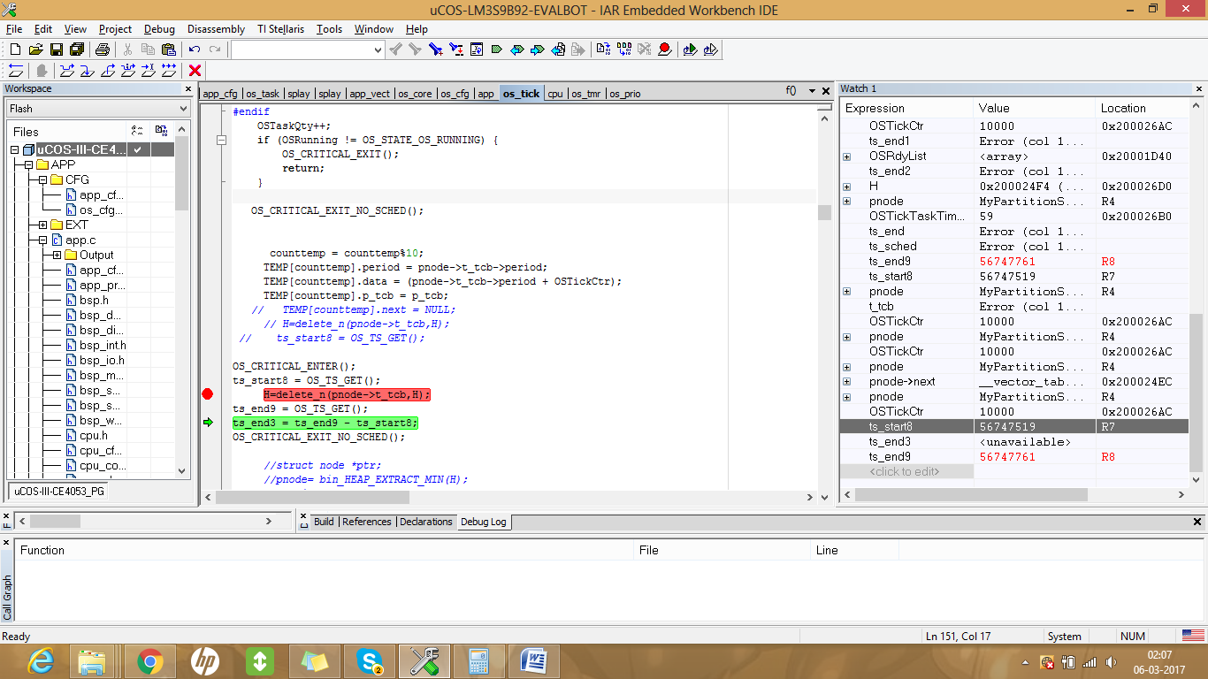

Average task deletion of node from tree: 242

Overheads using Binary Heap:

Pop operation overhead -> 94

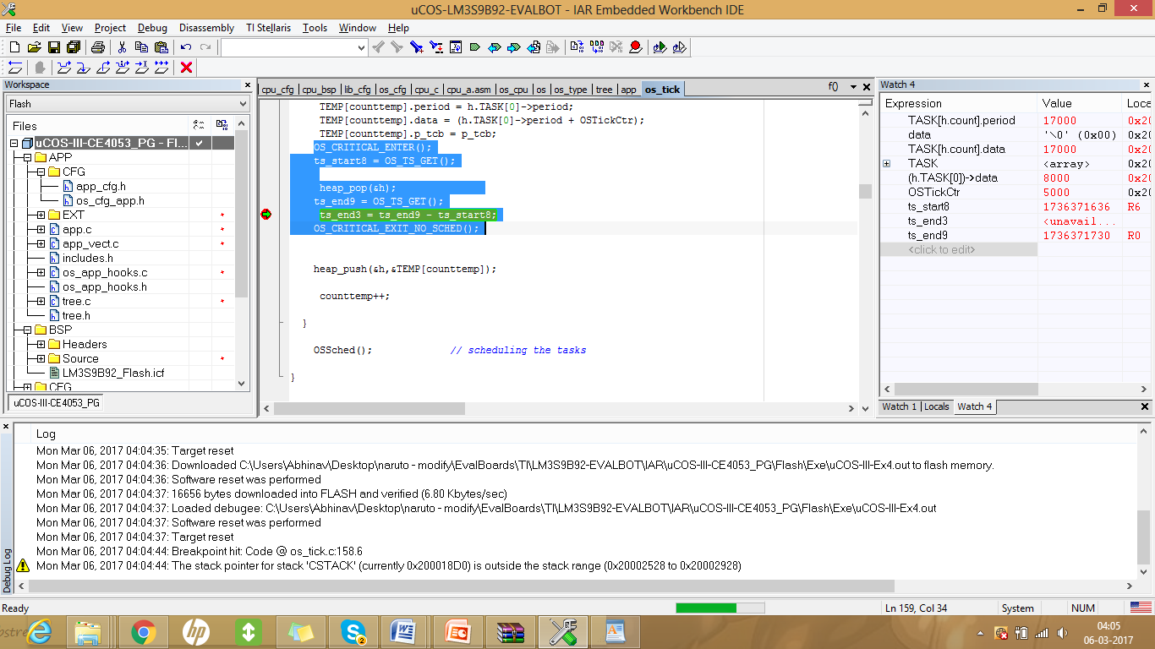

Push operation overhead->82